No AI Used
Student ID: 48576158
Unit: COMP8410 — Assignment 1
Repository: yash1998-MQ-AI/COMP8410-A1-48576158 (private, GitHub)
All times are stated with their time zone. Git commit times are in Sydney local time (AEDT, UTC+11). File modification times from the raw evidence listing are in UTC and are labelled as such or converted to AEDT.

Evidence
This section provides verifiable, full-cycle evidence — version history, implementation platforms and processes — showing how the evaluation was undertaken: how the evaluation data and source code were produced, how the evaluation methods were implemented, the baselines/benchmarks used, the justification of evaluation metrics, and how the submissions were developed. Every claim below is backed by artefacts that can be re-checked (git history, Google Colab revision view, file timestamps, environment snapshots and a cost log).

1. Version history: incremental development over 7 working days
The project is version-controlled in a private GitHub repository with a full commit history:
- 46 commits as of 9 Nov 2026 (re-run git rev-list --count HEAD immediately before submission, as this number may change), every one authored as Mugi98 with my personal email (yash.nimbalkar1998@gmail.com).
- Commits run from 29 Oct 2026, 15:22 AEDT (commit 3a8e3d3, "FIrst Commit Just Layout") to 9 Nov 2026, 01:59 AEDT (commit 8414913, "Raw Evidence.,Report and presentation with report."). The main experimental work spans 7 working days (29 Oct – 5 Nov): 13, 9, 7, 1, 4, 4 and 6 commits per day.
- The history shows incremental work rather than bulk uploads: early structural commits ("SET A and B are added with evaluation models", "metrics file."), mid-cycle debugging ("new run for qwen out of space problem", "W4: space-free work dirs"), and result milestones ("Splatfacto vs Nerfacto done.", "results for w5 and w6", "score from eval dataset").
- Several commit messages are short placeholders ("asdsad", "dfsfsdf", "aSAsAS"). These are work-in-progress checkpoints; they occurred at various times of day (including mid-afternoon on 5 Nov) and simply mark saving state during the work session. Optional: add your own one-line reason here, e.g. why you checkpointed at those moments — you know this best.

2. Corroboration from Google Colab's revision view
All 8 notebooks (colab/a1_week2.ipynb … colab/a1_week8.ipynb) carry native Google Colab metadata and a GPU accelerator setting. Colab's revision view (File → Revision history) records when the notebooks were saved and corroborates the git commit timestamps — the revision entries below line up with the corresponding commits to the minute:
- Week 3 (PuLID v1.1 vs InstantID): Colab revision dated 30 Oct 2026, 12:53 AM, titled "Strip notebook outputs, log W3 cost and results." — matches git commit 096b982 (30 Oct 2026, 00:53:35 AEDT).
- Week 4 (Nerfacto vs 3D Gaussian Splatting): Colab revisions at 30 Oct, 7:59 PM ("nerfstudio pair, notebook, scripts"), 11:14 PM ("pycolmap poses"), 11:20 PM ("asdsaas") and 31 Oct, 1:33 AM ("Splatfacto vs Nerfacto done.") — matching commits a8ecebc, a3b2260, f476b14 and b70b86f respectively.
In total, five Colab revision entries (weeks 2, 3 and 4) match git commits to the minute. This shows the notebooks were developed and run on Colab and committed to git as milestones were reached. (Note: for notebooks opened from GitHub, Colab's view largely mirrors my own commits, so this is presented as corroboration, not as an independent record.)
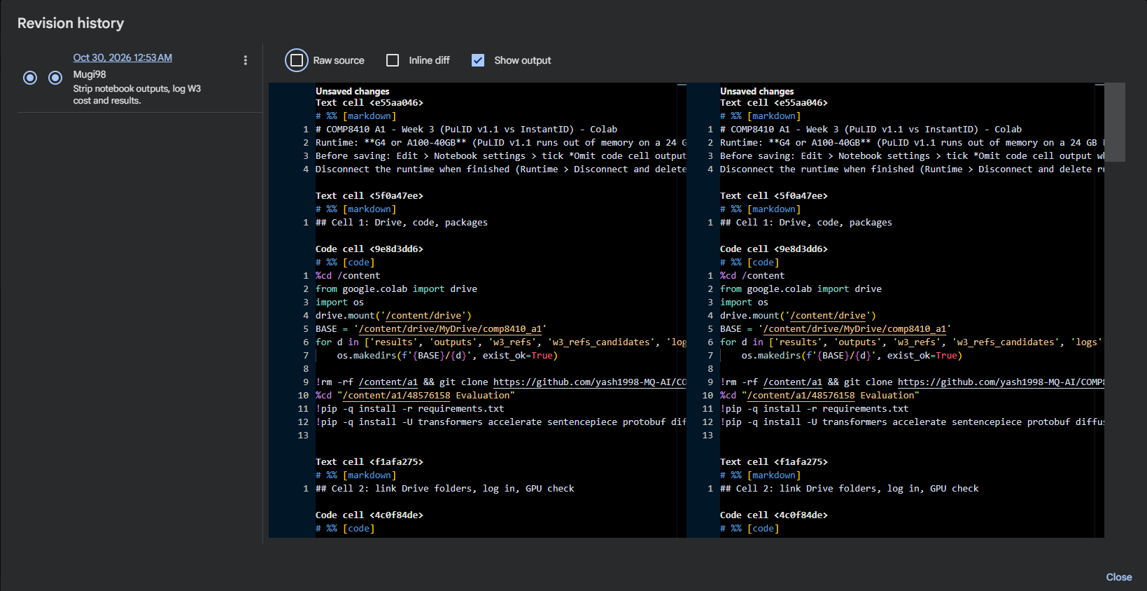
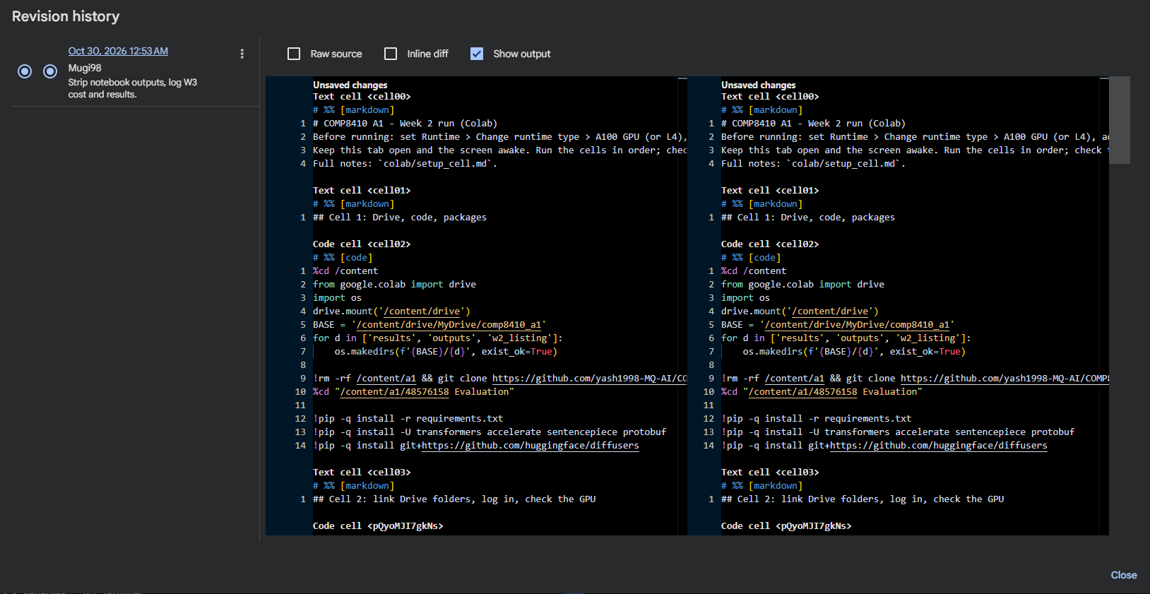
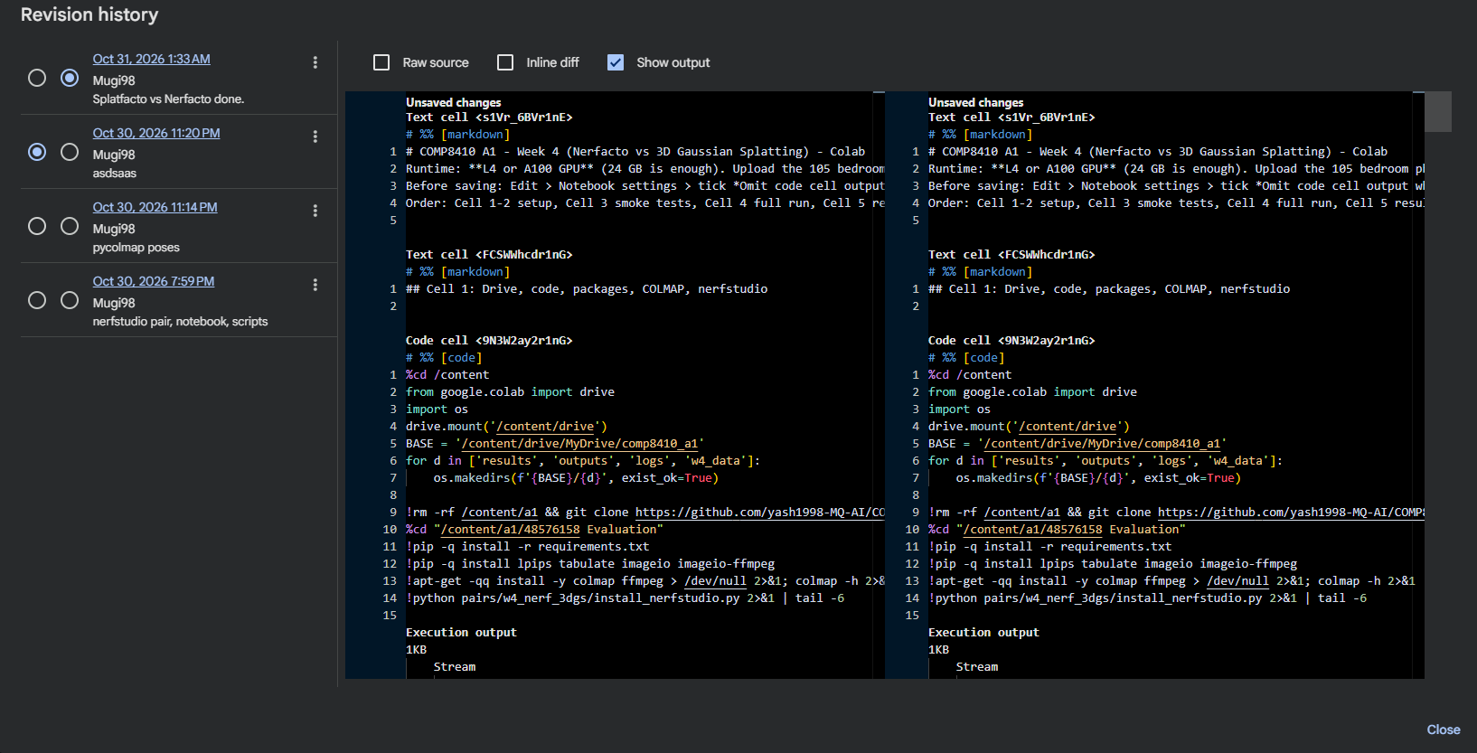

3. Full-cycle working evidence
The work is documented end-to-end, from raw capture to final deliverables:
- Raw capture photos: 129 original photos taken by me — 128 dated 29 Oct 2026 and 1 dated 31 Oct 2026 — forming the evaluation datasets (e.g., the 105 bedroom photos used for the Week 4 NeRF/3DGS comparison, referenced in the Week 4 notebook instructions).
- Source-code evolution: every code file, notebook and config has a modification time between 29 Oct and 5 Nov 2026 (UTC), in week order — Week 2 files first, Week 8 files last. Each week's pair follows the same hand-built structure: prepare_items/prepare_inputs → run/gen → score → report → tests, showing a consistent, self-designed evaluation harness (a1eval/) reused and extended week by week.
- Environment snapshots: full environment dumps exist for weeks 5, 6 and 7 (results/w5_ENV_hunyuan.txt, w5_ENV_trellis2.txt, w6_ENV.txt, w7_ENV.txt), so every reported result is tied to an exact software environment.
- Cost log: cost_log.csv records Colab Pro spending on three dates (29 Oct, 30 Oct and 2 Nov 2026: A$3.29, A$1.54 and A$1.17), with compute-unit balances read from the Colab Resources panel. Some figures in its notes are explicitly stated as assumptions (an assumed start balance of 100 units, and an assumed A100 usage rate of 11.77 units/hr); these are marked as assumptions in the log itself.

4. How the evaluation was implemented
- Evaluation data: generated from the raw captured photos and per-week configs (pairs/*/config.yaml), with deterministic preparation scripts (prepare_items.py, prepare_inputs.py, make_synthetic_refs.py) and frame-selection tooling (tools/select_frames.py).
- Evaluation methods: a custom harness (a1eval/ — schema.py, metrics.py, aggregate.py, runlog.py) implements the scoring pipeline; each week has its own score_wN.py and report_wN.py, plus unit tests (tests/test_harness.py, test_w2.py … test_w8.py).
- Baselines/benchmarks: each week compares two systems head-to-head:
  - W2 image editing: Qwen-Image-Edit vs FLUX
  - W3 identity preservation: PuLID v1.1 vs InstantID
  - W4 NeRF/3DGS: Nerfacto vs Splatfacto (3D Gaussian Splatting)
  - W5 image-to-3D: Hunyuan3D vs TRELLIS 2
  - W6 video generation: Wan2.2 TI2V-5B vs HunyuanVideo 1.5
  - W7 video editing: Wan2.1-VACE-1.3B vs Lucy-Edit-Dev
  - W8 agents: UI-TARS-1.5-7B vs MAI-UI-8B / Holo (candidates)
- Metrics used (from the configs and scorers): ArcFace identity similarity (W3); CLIP-based edit alignment clip_t, frame flicker, masked PSNR on unedited regions, latency and peak VRAM (W7); task success, steps taken, latency and injection pass rate (W8).
- Metric justification: Write this paragraph yourself, from memory: one or two sentences per metric family on why you chose it — e.g. why ArcFace cosine similarity is the right measure for identity preservation, why masked PSNR isolates edit locality, why task_success/injection_pass capture agent capability and safety. Only you can state your reasoning authentically.

5. Supporting check: no AI-assistant tooling found
As a supporting check (not primary evidence), a full-text search of the repository — code, notebooks, text and all commit messages — finds no AI-assistant tool names. The only occurrences of the string "openai" are the CLIP model identifier (an open-source scoring model used as a metric) and a pip package version pin in the environment snapshots; notebook matches are limited to that model name and base64 noise. Absence of tool names alone does not prove non-use — it is offered only as support for the evidence above.

6. Submission development
The final deliverables were assembled after the experimental work was committed (times converted from the UTC file listing to Sydney time, AEDT):
- Report PDF: 48576158_Assignment_1_Report.pdf — 8 Nov 2026, 16:10 AEDT
- Presentation: 48576158_Assignment_1_Presentation.pptx — 8 Nov 2026, 18:50 AEDT
- Video: COMP8410_Assignment_1_48576158.mov — 9 Nov 2026, 01:15 AEDT
This ordering (experiments → results → report → slides → video) across late October to early November reflects a sequential authorship process.

7. How to verify this evidence
- Clone the repository and run git log --format='%h | %ad | %an | %ae | %s' — commit timestamps and authorship are as stated above (46 commits as of 9 Nov 2026).
- Open any colab/a1_weekN.ipynb in Google Colab → File → Revision history — the revision timestamps match the corresponding git commits.
- Check the file modification times, environment snapshots (results/*_ENV*.txt) and cost_log.csv in the repository.
- Search the repository for AI-assistant tool names — none exist beyond the CLIP model identifier and the pip package pin.

Declaration: I declare that the work submitted for COMP8410 Assignment 1 is entirely my own, and that no AI writing or coding assistant was used to produce the code, analysis, report, presentation or video. The evidence above is verifiable and covers the full life-cycle of the submission.

